**KALITHAS.V** 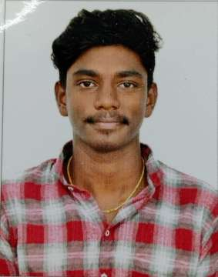

D.O.B: 27/01/2002

E-mail: aariyankali2002@gmail.com

Phone no : 9025471845

Present Address: 1/20B LK Homes, 1st Main road

Venkateswara Nagar, Ramapuram, Chennai-600 089.

**CAREER OBJECTIVE:**

Looking forward to an entry-level position to start my career. I am adaptable and a quick learner. I can assure you of my professional and personal growth because I have what it takes to forge a successful path for both the company and my future.

**ACADEMIC CREDENTIALS:**

* 2017-2021: SRM Institute of Science & Technology (CGPA:7.32)
* 2016-2017: Assisi Matriculation Higher Secondary School Passed with distinction (74.8%) 12th Standard
* 2014-2015: Assisi Matriculation Higher Secondary School Passed with distinction (82.3%) 10th Standard

**TECHNICAL SKILLS:**

• Basics of Photoshop.

• Basics of Graphic Design

• Basics of Illustration.

• Copy Writing

• Assistant Director

**PERSONAL STRENGTH:**

• Attention to details.

• Innovative mind.

• Good communication skill.

• Adaptability.

**HOBBIES:**

* Photography
* Editing
* Script writing

**PERSONAL DETAILS:**

Name : Kalithas.V

Father name : Vinodkumar

Date of Birth : 27.01.2002

Nationality : Indian

Language known : English and Tamil

Contact no. : 9025471845

E-mail : aariyankali2002@gmail.com

**I hereby affirm that all the information furnished above in this resume is true and correct to the best of my knowledge and belief .**

Place : Chennai Yours Faithfully

Date : Kalithas.V